COAL – Fall 2021
Lab Manual 1 - Introduction
Activity 1: Setup
Make a separate folder COAL and NASM in your machine for example “D:\COAL\NASM”. Visit the link given below. Download and install NASM, AFD and DOSBOX, according to the instructions, in your NASM folder.
http://wetolearn.blogspot.com/2013/09/setting-up-afd-nasm-and-dosbox-for-8086.html
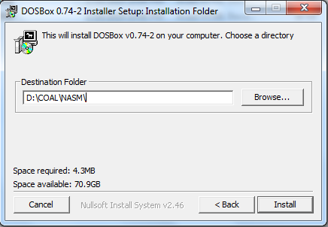
After installations double click “DOSBox 0.74-2 Options.bat” file and at the end of the file paste following lines:
MOUNT C D://COAL//NASM
C:
(We are mounting C drive to our folder where we have saved AFD and we will save our .asm file in this directory)
You may follow links given below for Video Tutorial of Setup:
Tutorial part 1: https://drive.google.com/file/d/1N3lWL8hsN0ZbhF3tlNwCWWwjJ_eHQqk6/view?usp=sharing
Tutorial part 2: https://drive.google.com/file/d/10p8qyaOVOwF5lDighrMKE-uNYQX-c3bL/view?usp=sharing
AFD: https://drive.google.com/file/d/1eXnD3JEwBelFiJT6iIk7gluudV2Fu_iX/view?usp=sharing
NASM: https://drive.google.com/file/d/1ZoeE2MxjNaK7DdJKCacYfAJyn006MI_F/view?usp=sharing
Dosbox: https://drive.google.com/file/d/1DnaDIk4RoGBFDP1y4Dr3q89xwM3gx1d1/view?usp=sharing

Activity 2: Running your First Program
Follow these step in order to run your first program:
- Copy/paste following code in notepad
; this is a comment. Comment starts with semicolon
; this program adds three numbers in registers

[org 0x0100] ;we will see org directive later

mov ax, 5 ; AX = 5
mov bx, 10 ; BX = 10
add ax, bx ; AX = AX + BX
mov bx, 15 ; BX = 15
add ax, bx ; AX = AX + BX

mov ax, 0x4c00 ;terminate the program
int 0x21

- Save this file as “ex01.asm” in your NASM folder e.g. “D:\COAL\NASM”:
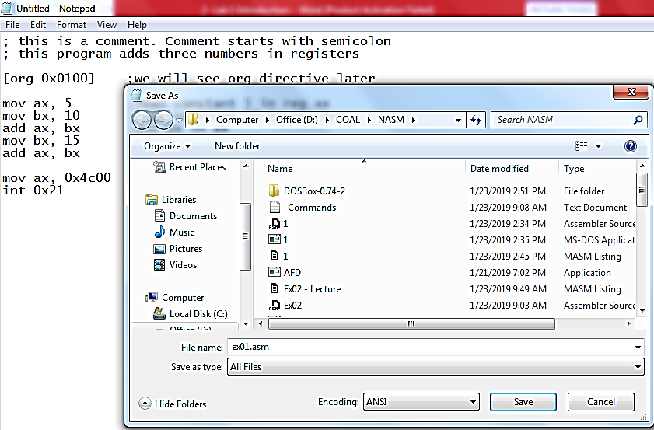
- Go to NASM installation directory ( e.g. “D:\COAL\NASM”). Double click nasmpath.bat (batch file) and type following command there. (Your .asm file and nasm should be in one folder)
nasm ex01.asm -o ex01.com -l ex01.lst
- Above command will assemble your code and create ex01.com and ex01.lst files. Open ex01.lst file in notepad.
  - What is opcode of instruction “mov ax, someConstant”
  - Verify the above opcode everywhere the instruction has been used.
  - What does “B80500” mean?
  - Verify the opcode of instruction “mov bx, someConstant” throughout the machine code.
  - What is the offset of first instruction?
  - Why are offsets of second and third instructions 3 and 6?
  - What should be the size of ex01.com file?
  - Right click ex01.com and verify its size.

- Open DOSBox (by double clicking dosbox.exe), following window will appear:
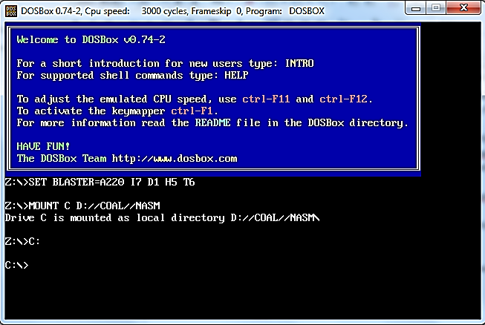
- Write following command and press enter.
Afd ex01.com
(Your AFD.exe should be in same directory where we have installed everything)
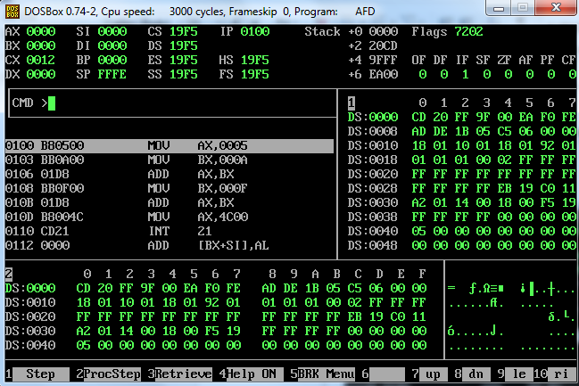

- Above command will open the debugger and load your ex01.com file in it.
  - What is the value of IP register? And what will be its effect?
  - Note the initial values of data registers
  - Press F1 and watch the values of data registers
Activity 3: Explore different functions available in debugger

